RARS!
Roll it, add it, roll it, subtract it!
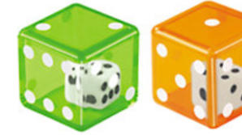
Materials: snap cubes, double dice or one that has up to 10, a single die with a max of 5, Roll It key
- Start with 3 cubes.
- Roll the double dice. Add them. Remember the total!
- Roll the single die. Subtract it from the total.
- Use the total to take or lose cubes.
- Whoever gets 20 cubes first, wins! Then repeat.

Total |  | Cubes
2 |  | +1
3 |  | 0
4 |  | -1
5 |  | +2
6 |  | 0
7 |  | -3
8 |  | +3
9 |  | 0
10 |  | +2
11 |  | -2
12 |  | +4
RARS… I mean, ROAR!!



